

S.PREETHAM CHANDRAN CH.SC.U4CSE24139

OBJECTORIENTEDPROGRAMMING (23CSE111) LABRECORD



**AMRITA VISHWA VIDYAPEETHAM AMRITA SCHOOL OF COMPUTING, CHENNAI**

**BONAFIDE CERTIFICATE**

This is to certify thattheLabRecordworkfor23CSE111-Object Oriented Programming Subject submitted by ***CH.SC.U4CSE24139–S.PREETHAM CHANDRAN*** in**“Computer**

**Science and Engineering”** is a Bonafide record of the work carried out under my guidance and supervision at Amrita School of Computing, Chennai.

This Labe xamination held on 13/3/25

InternalExaminer1 InternalExaminer2

INDEX



|  |  |  |
| --- | --- | --- |
| **S.NO** | **TITLE** | **PAGE.NO** |
| UMLDIAGRAM | | |
| 1. | **ATM WITHDRAWL** | |
|  | 1.a)UseCaseDiagram | 4 |
|  | 1.b)ClassDiagram | 5 |
|  | 1.c)SequenceDiagram | 5 |
|  | 1.d)ObjectDiagram | 6 |
|  | 1.e)State-ActivityDiagram | 6 |
| 2. | **HOSPITAL MANAGEMENT** | |
|  | 2.a)UseCaseDiagram | 7 |
|  | 2.b)ClassDiagram | 8 |
|  | 2.c)SequenceDiagram | 8 |
|  | 2.d)ObjectDiagram | 9 |
|  | 2.e)State-ActivityDiagram | 9 |

UMLDIAGRAMS

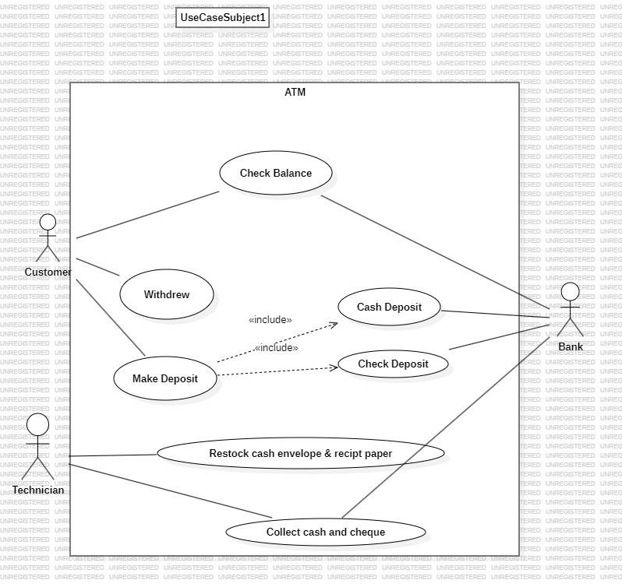

1. ATM WITHDRAWL

**UseCaseDiagram:**

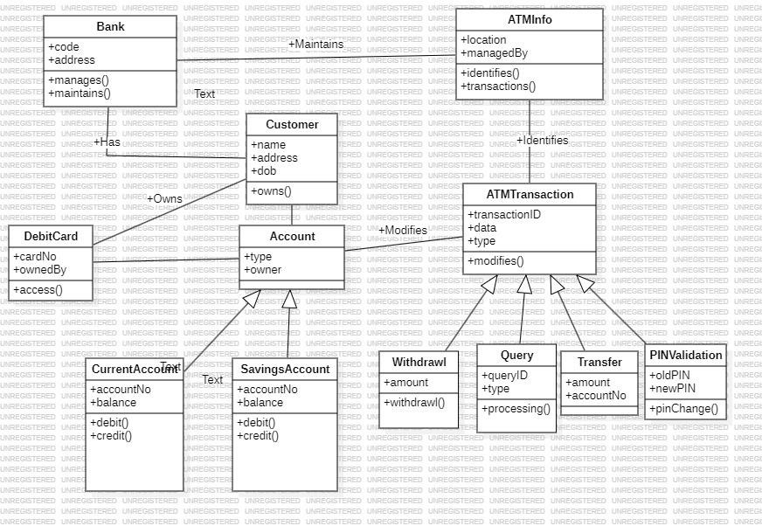

**ClassDiagram:**

**SequenceDiagram:**

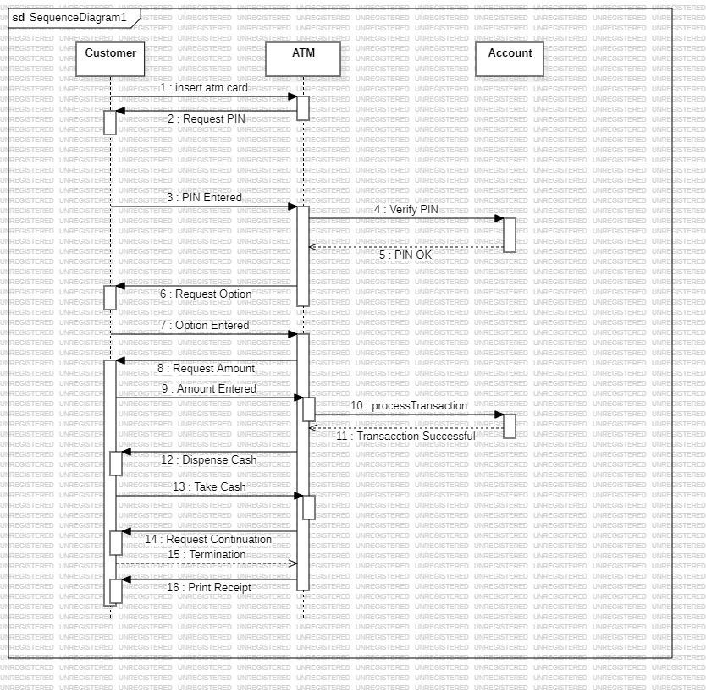

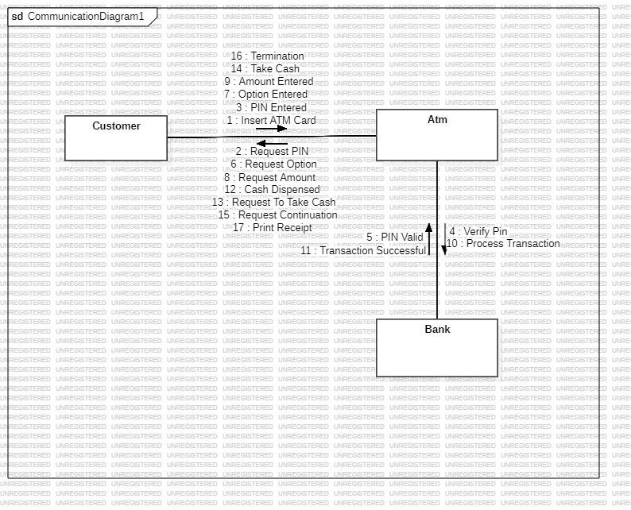

**ObjectDiagram:**

**State-ActivityDiagram:**

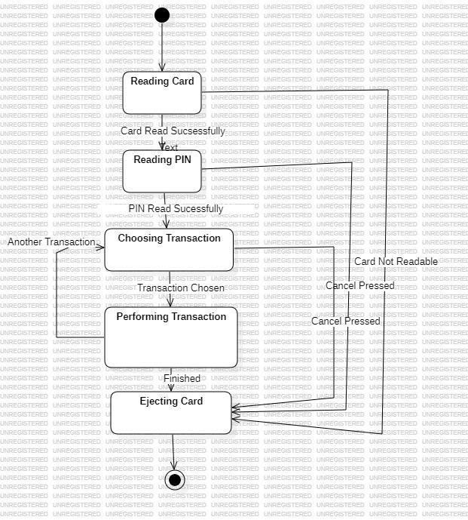

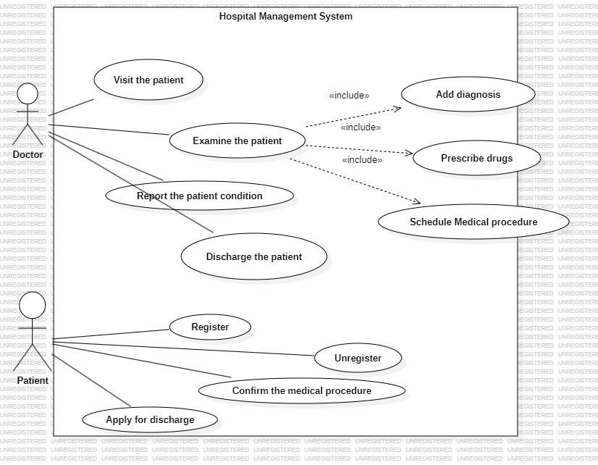

1. **HOSPITAL MANAGEMENT SYSTEM**

**UseCaseDiagram:**

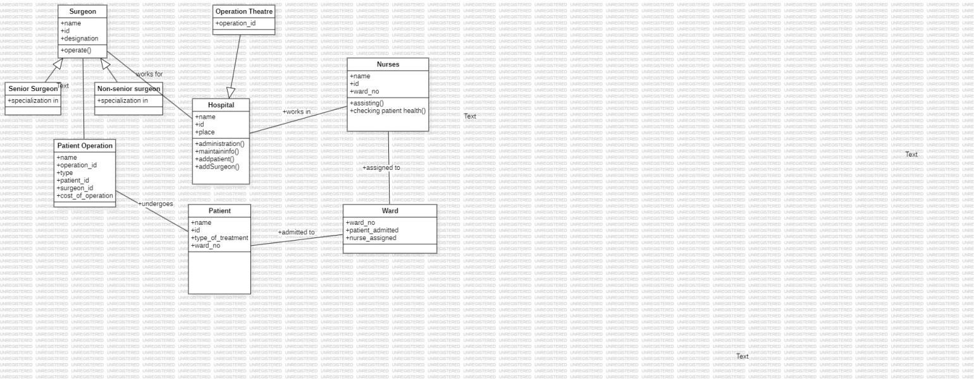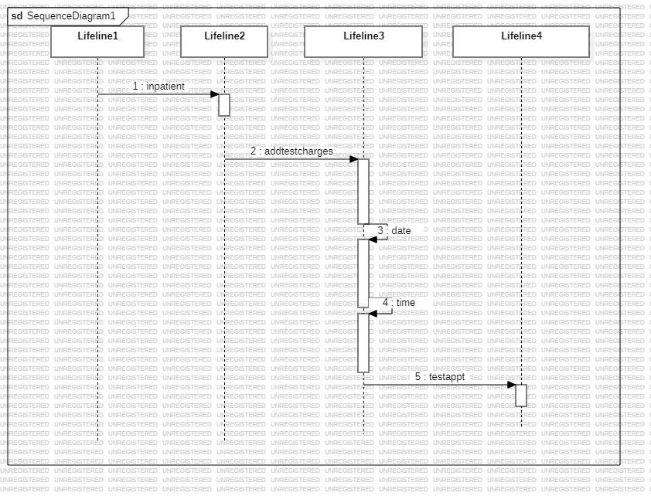

**ClassDiagram:**

**SequenceDiagram:**

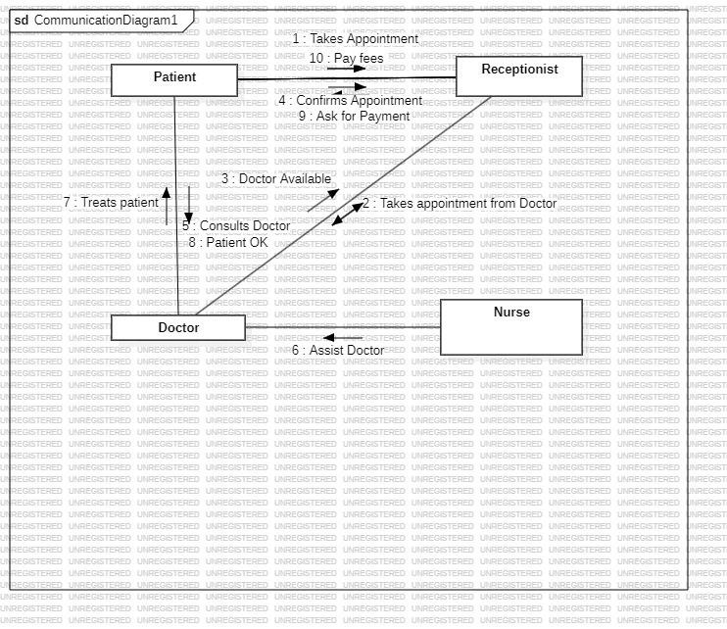

**ObjectDiagram:**

**State-ActivityDiagram:**

